**Data Structure Notes**

**Linked-List:**

* **Introduction:**
  + A linked list is a data structure that can store an indefinite amount of items. These items are connected using pointers in a sequential manner.
  + A visual representation of a single node and the complete data structure can be seen below:

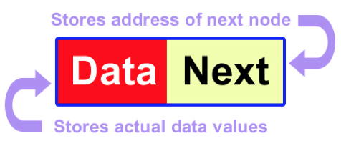

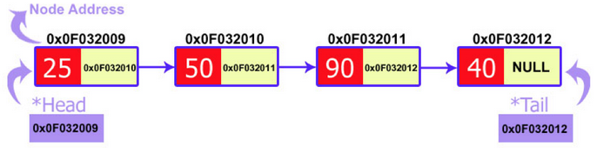

**Figure 1: Visual Representation of a Singly Linked List**

* + Each element in a linked list is called a node. A node contains some data and a single pointer or multiple pointers. In a singly linked list the node only contains one pointer, which points to the memory address of the next node in the linked list. For a doubly linked list the node contains a pointer to the next node in the list and the previous node in the list.
  + There are multiple types of linked lists:
    - Singly Linked List
    - Circular Linked List
    - Doubly Linked List
* **Linked Lists vs. Arrays:**
  + The size of arrays is fixed, and the memory is pre allocated.
  + Inserting a new element into an array when it is full, requires that a new array of a larger size is created and we insert each element of the old array into the new array. This process is costly in both time and space for arrays.
  + Advantages of Linked Lists over arrays:
    - Dynamic Size
    - Ease of Insertion/Deletion
  + Drawbacks:
    - We have to access each element sequentially with linked lists, which takes O(n) in the worst case, whereas with arrays it is constant time look up.
    - Linked list requires more space than arrays. The reason being that each node of the Linked List stores not just the data but also the memory address of the next node in the list.
* **Singly Linked List Implementation:**
  + The main difference between singly linked lists and doubly linked lists is the structure of the node. The node for a singly linked list will point only to the next memory address, whereas the doubly linked list will point to the next and previous memory address of the node.
  + The structure of the node for a singly linked list can be seen below:

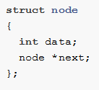

* + Linked List Operations:
    - Checking whether the list is empty.
    - Appending to a node.
    - Prepending to a node.
    - Inserting a node.
    - Deleting a node (either by index or data value).
    - Reversing a linked list.
    - Traversing a linked list.
  + Adding a node to the list: Appending a new node to the end of a linked list has 2 steps:
    - First we need to link the address of the new node, to the next_ member of the current tail node.
    - The second step is to then update the tail so that it is the new node is now the tail of the linked list.

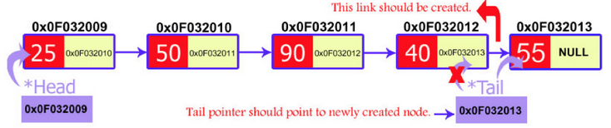

**Figure 2: Visual Representation of appending a new node to the end of the list**

* + Insertion: Inserting a new node into a linked list has three specific cases: inserting at the start, inserting at the end (which we over in the previous section), and inserting at a particular position in the list.
    - Insertion at the start:
      * We first need to set the next_ field of the new node to the head of the linked list.
      * Then set the head of the link list equal to the new node.
    - Insertion at a specified position:
      * We pass the address of the new node in the next_ field of the previous node.
      * We pass the address of the current node in the next_ field of the new node.
  + Deletion: Similar to insertion, deletion has three specific use cases: deletion at the start, at the end, and at a specified position.
    - Deletion at the start:
      * Create a temporary node and pass it the address of the head node.
      * Set the second node equal to the head.
      * Delete the temporary node.
    - Deletion at the end:
      * Iterate to the second to last node
      * Set a temp node equal to the tail and delete it.
      * Set the tail equal to the second to last node.
      * Set the new tail’s next pointer to null
    - Deletion at a specific point: We use two pointers to iterate through the linked list.
      * As we iterate through the list we have the current node and previous node.
      * Once we come to the specified position, we set previous node’s next field equal to the current node’s next field and then delete the current node.
* **Doubly Linked List Implementation:**
  + The structure of the node for a doubly linked list can be seen below:

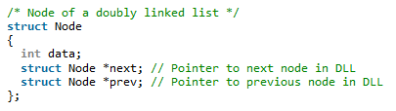

* + The operations are very similar to the singly linked list but we have more flexibility. Since we are not restricted to only iterating through the list by starting at the head of the list. We can start at the tail of the list and iterate to the head.
* **References:**

1. <https://www.codementor.io/codementorteam/a-comprehensive-guide-to-implementation-of-singly-linked-list-using-c_plus_plus-ondlm5azr>
2. <https://www.geeksforgeeks.org/data-structures/linked-list/>
3. <https://www.cs.cmu.edu/~ab/15-123S09/lectures/Lecture%2010%20-%20%20Linked%20List%20Operations.pdf>
4. <https://www.programiz.com/dsa/linked-list-operations>

**Stack:**

* **Introduction:**
  + A Stack is an abstract data type. It is a simple data structure that allows adding and removing elements in a particular order. Every time an element is added, that element goes to the top of the stack. The only element that can be removed is the element that is at the top of the stack. (word for word from reference 2).

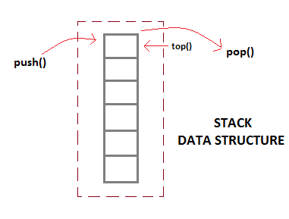

**Figure 3: Visual Representation of Stack Data Structure**

* + The order in which the collection of items is stored is said to be LIFO (Last In First Out) or FILO (First In Last Out).
  + There are a few **basic operations**, which are performed by the stack data structure:
    - Push: Adds an item in the stack. If the stack is full, then it is said to be an Overflow condition.
    - Pop: Removes an item from the stack, in reverse order. Meaning the last item pushed onto the stack is the first item to come off when pop is called. If the stack is empty and we try to pop, this is said to be an Underflow condition.
    - Peek or Top: Returns the top element of the stack, without removing it from the stack.
    - isEmpty: Checks if the stack is empty.
* **Implementation of Stack Data Structure:**
  + Two ways to implement a stack:
    - Array – The are quick but limited in size.
    - Linked List – requires overhead to allocate, link, unlink, and deallocate, but is not limited in size.
* **Applications:**
  + Parsing
  + Expression Conversion (Infix to Postfix, Postfix to Prefix etc)
  + Balancing of symbols
  + Redo-undo features at many places like editors, photoshop
  + Forward and backward feature in web browsers
  + Used in many algorithms like: Tower of Hanoi, tree traversals, stock span problem, histogram problem.
* **References:**

1. <https://www.geeksforgeeks.org/stack-data-structure-introduction-program/>
2. <https://www.studytonight.com/data-structures/stack-data-structure>

**Queue:**

* **Introduction:**
  + Similar to a stack, a queue is a linear data structure. The main difference between a queue and a stack is how the elements are stored. A stack object is defined as a LIFO (Last In First Out) data structure, whereas a Queue object is a **FIFO** (First In First Out) data structure.
  + There are two main operations performed on queues:
    - Enqueue – the process of adding an element into a queue.
    - Dequeue – the process of removing an element from a queue.
* **Operations:**
  + There are four basic operations performed on queues:
    - Enqueue – Add an element into a queue.
    - Dequeue – Remove an element from a queue.
    - Front – Returns the value at the front of the queue.
    - Rear – Returns the value at the end of the queue.
* **Implementations:**
  + The underlying implementations of queues can vary, as long as the operations of the queue stay the same. The most common implementations of queues are arrays, linked lists and stacks.
    - Array Implementation: In order to implement a queue using an array implementation, two indices must be known, the front and the rear. We enqueue an element at the rear and dequeue an element at the front. This highlights the FIFO structure. However, arrays are fixed size structures, which causes problems when we reach the end of the array. The solution to this problem is a **circular queue (5)**.
    - Linked List Implementation: Very similar to the array implementation. However, we don’t have to worry about the circular queue issue, because we are no longer dealing with a fixed size structure.
    - Stack Implementation: Another implementation of queues is with multiple stacks. In order to perform a Enqueue we only need one stack that we can push data onto. For a Dequeue we need two stacks. For more specific implementation details look at reference (6).

* **Applications:**
  + Multiple user requests of a single shared resources. (printer, CPU task scheduler, Disk Scheduling)
  + IO Buffers, pipes, file IO, etc.
  + Breadth-First Searches
* **References:**

1) <https://www.geeksforgeeks.org/queue-data-structure/#intro>

2) <https://www.cs.cmu.edu/~adamchik/15-121/lectures/Stacks%20and%20Queues/Stacks%20and%20Queues.html>

3) <https://www.studytonight.com/data-structures/queue-data-structure>

4) <https://introcs.cs.princeton.edu/java/43stack/>

5) <https://www.studytonight.com/data-structures/circular-queue>

6) <https://www.studytonight.com/data-structures/queue-using-stack>

**Binary (MIN/MAX) Heaps:**

* **Introduction:**
  + A binary heap is a complete binary tree which satisfies the heap ordering property. The ordering can be one of two types:
    - The *min-heap* property: the value of each node is greater than or equal to the value of its parent, with the minimum-value element at the root.
    - The *max-heap* property: the value of each node is less than or equal to the value of its parent, with the maximum-value element at the root.

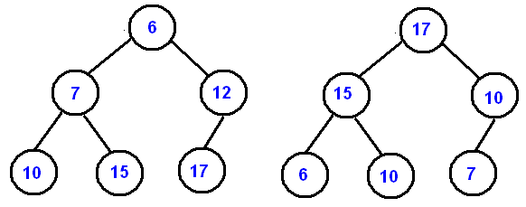

**Figure 4: Example of a Min Binary Heap (left) and a Max Binary Heap (right)**

* **Array Implementation:**
  + We can uniquely represent a complete binary tree with an array. The level order traversal of the tree is stored in the array.
  + Some implementations include leaving the first element of the array open and storing the root element as the second item. Others have the root value as the first element of the array. Either way we can visualize the storing of a binary tree in the examples below.

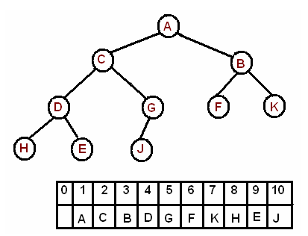

**Figure 5: Level-Order Binary Tree Array Storing**

* + Index from 1:
    - Arr[i/2]: returns the **parent** node of index i.
    - Arr[(2*i)]: returns the **left** child node of index i.
    - Arr[(2*i) + 1]: returns the **right** child node of index i.
  + Index from 0:
    - Arr[(i – 1)/2]: returns the **parent** node of index i.
    - Arr[(2*i) + 1]: returns the **left** child node of index i.
    - Arr[(2*i) + 2]: returns the **right** child node of index i.
* **Insert:**
  + When we insert a new value into the heap, we put that value at the end of the array. Then we compare that value with its parent, if it is larger (for max heap) or smaller (for min heap) than the parent’s value we swap the nodes. If not, we leave it.
* **Extract Minimum:**
  + To Extract/Delete the minimum value from the heap we swap the min with the last element of the array and discard the last element. We have to make sure that we restore the property of the heap, which is known as heapify. We do this with the sink-down method (5).
    - If the parent node is larger than either of the child nodes. Compare the child nodes, which every of the two nodes are smaller swap with the parent node.
    - Proceed down the tree until the parent node is smaller than the child node.

**[](Delete-OR-Extract-Min-from-Heap.gif)**

**GIF 1: Press ctr + click to see the animation.**

* **Delete A Node:**
  + Find the index for the element to be deleted.
  + Take out the last element from the last level from the heap and replace the index with this element.
  + Perform the Sink-Dow method.
* **Comparative Time and Space Complexity:**

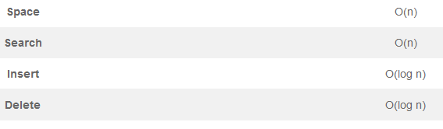

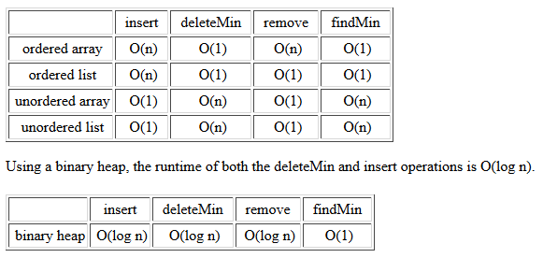

**Figure 6: Time Complexity Comparisons**

* **Applications:**
  + Priority Queue
  + Heap Sort
  + Graph Algorithms: The priority queues are especially used in Graph Algorithms like Dijkstra’s Shortest Pat and Prim’s Minimum Spanning Tree.
  + K’th Largest Element in an array
  + Sort an almost sorted array.
  + Merge K sorted arrays.
* **References:**

1. [**https://www.cs.cmu.edu/~adamchik/15-121/lectures/Binary%20Heaps/heaps.html**](https://www.cs.cmu.edu/~adamchik/15-121/lectures/Binary%20Heaps/heaps.html)
2. [**https://www.geeksforgeeks.org/binary-heap/**](https://www.geeksforgeeks.org/binary-heap/)
3. [**https://www.youtube.com/watch?v=WCm3TqScBM8**](https://www.youtube.com/watch?v=WCm3TqScBM8)
4. [**https://algorithms.tutorialhorizon.com/binary-min-max-heap/**](https://algorithms.tutorialhorizon.com/binary-min-max-heap/)

**Binary Trees:**

* **Introduction:**
  + A tree is a hierarchical, non-linear data structure. Every tree contains nodes, these nodes store data and have pointers to other nodes called leaves. We have a topmost node called the root node. From the root node we work are way down the tree with child nodes. We can visualize the tree data structure below:

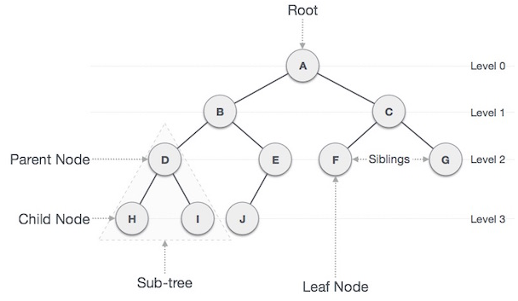

**Figure 7: Visualization of a tree data structure. (6)**

* + Some important terminology associated with tree structures are the following:
    - *Root*: The topmost node of a tree.
    - *Parent*: Any node that contains child nodes, and isn’t the root node.
    - *Child*: A node that is connected below another node.
    - *Leaf*: A node that does not have a child node.
    - *Edge*: The connection between two nodes.
    - *Height*: The height of a tree is the length of the tree, is the number of nodes from the root to the bottommost leaf – 1. E.g. the height of the tree in figure 7 is 3.
    - *Depth*: This is associated with a node. So the depth of a specific node is the length from that node to the root. E.g. in figure 7. The depth of node C is 1 and the depth of node H is 3.
    - *Subtree*: A nice property of trees is that each child node has its own sub tree, or a subset of the whole tree.
  + There are many types of trees but one of the most common trees are Binary Trees, which will be the focus of this section. A binary tree is defined by the node, where every node is limited to at most 2 child nodes (typically named left and right).
* **Properties:**
  + Maximum number of nodes per level is equal to 2L, where L is the level. E.g. the Level of the root node is 0, 20 = 1.
  + Maximum number of nodes in a binary tree of height h is equal to 2h – 1.
  + In a binary tree, the number of leaf nodes is always one more than nodes with two children.
    - L = T + 1
      * L = Number of leaf nodes
      * T = Number of internal nodes with two children.
    - Proof can be shown in reference 2.
* **Types of Binary Trees:**
  + *Full Binary Tree*: A Binary tree is said to be full if every node in the tree has either 0 or 2 child nodes. Examples of full binary trees are seen below:

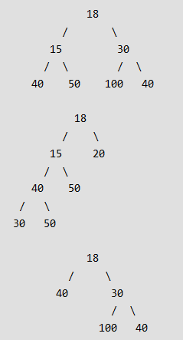

**Figure 8: Examples of Full Binary Trees.**

* + *Complete Binary Tree*: A binary tree is said to be complete if all levels of the tree are completely filled, with the possible exception of the last level. Examples of complete binary trees can be seen below:

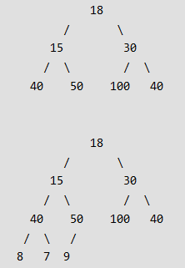

**Figure 9: Examples of Complete Binary Tree**

* + *Perfect Binary Tree*: A Binary tree is said to be a perfect when all internal nodes have 2 child nodes and all the leaves are at the same level. Examples of a perfect binary tree can be seen below:

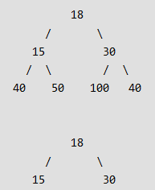

**Figure 10: Examples of Perfect Binary Tree**

* + *Balanced Binary Tree*: A binary tree is said to be balanced if the height of the tree is O(Log *n*), where *n* is the number of nodes. Different types of trees, such as AVL and Red-Black trees maintain this property differently, which will be discussed in a later section.
  + *A Degenerate (or Pathological) Tree*: A tree where every internal node has only one child node. In terms of performance this tree is equivalent to a linked list.
* **Operations:** Below is a list of basic operations on binary trees.
  + Insert – Insert a node or an entire sub tree to a node.
  + Search – Search for specific items in a tree.
  + Traversal – There are four main methods of Tree traversals
    - Breadth First Traversal (or level order traversal)
    - Depth First Traversal:
      * Preorder:
      * Inorder:
      * Postorder:
* **Implementation:**
  + Tree Traversal: There are two categories of tree travers Breadth First Traversal or Depth First Traversal: (We can visualize the different traversal methods in figure 11)
    - Breadth First Traversal: This is also called level order traversal, where we start from the root node and traversal down level by level.
    - Depth First Traversal: In this category of traversal we work our way down to the bottom leafs first and traverse back up to the top. There are three different types of Depth First Traversals:
      * Inorder (Left-Root-Right)
      * Preorder (Root-Left-Right)
      * Postorder (Left-Right-Root)

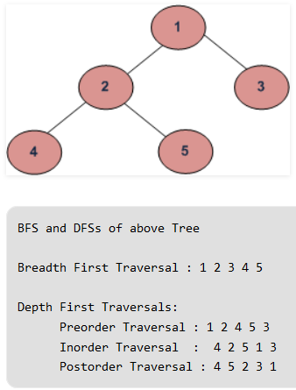

**Figure 11: Different Traversal Methods (7)**

* **Applications:** 
  + More efficient searching of data.
  + To represent hierarchical data.
* **References:**

1. <https://www.geeksforgeeks.org/binary-tree-set-1-introduction/>
2. <https://www.geeksforgeeks.org/binary-tree-set-2-properties/>
3. <https://leetcode.com/explore/learn/card/data-structure-tree/>
4. <https://medium.com/the-renaissance-developer/learning-tree-data-structure-27c6bb363051>
5. <https://en.wikipedia.org/wiki/Tree_(data_structure)>
6. <https://www.tutorialspoint.com/data_structures_algorithms/tree_data_structure.htm>
7. <https://www.geeksforgeeks.org/bfs-vs-dfs-binary-tree/>
8. <https://en.wikipedia.org/wiki/Tree_traversal>

**Binary Search Trees:**

* **Introduction:**
  + Binary Search tree exhibits a special behavior. A node's left child must have a value less than its parent's value and the node's right child must have a value greater than its parent value. There are only two child nodes per parent node in a binary search tree.
  + The properties of a binary search tree (BST) are the following:
    - The left sub tree will only contain key values less than the current node’s key value.
    - The right sub tree will only contain key values greater than the current node’s key value.
    - All subtrees are themselves binary search trees.
  + An Example of a BST can be seen in figure 12.

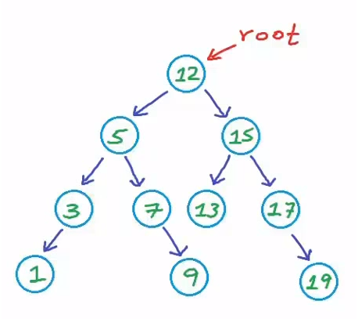

**Figure 12: Binary Search Tree Example**

* **Implementation:** (The implementations can typically be done with or without recursion)
  + Insertion: (Time Complexity: O(h), where h = height of tree)
    - Start from the root node:
    - Compare the value of the current node to the value of the root node.
    - If the value is less than or equal to the value of the root node, proceed to the left child node.
    - If the value is greater than the value of the root node, proceed to the right child node.
    - Repeat this comparison until you reach a null node. Which is where you will insert the new value.
  + Search: (Time Complexity: O(h), where h = height of tree)
    - Start from the root node and compare the key value with the value you are searching for. If they are equal return the root node.
    - If the value you are searching for is not equal to the value of the root node, compare that value to the root value.
    - If the value is less than move to the left child and node and compare the values.
    - If the value is greater than move to the right child node and compare the values.
    - Continue these comparisons until you find the value you are searching for.
    - If the value is not in the tree return a null pointer.
  + Delete: This is slightly more complex than the other operations, because there are multiple cases that need to be handled: (Time Complexity: O(h), where h = height of tree)
    - A node with no children (leaf node):
      * Delete node.
    - A node with just one child:
      * In this case we need to keep track of the parent node.
      * If the parent’s left child is the node we are looking to delete, we set the parents left child to the node’s child. Then delete the node.
      * If the parent’s right child is the node we are looking to delete, we set the parent’s right child to the node’s child. Then delete the node.
    - A node with two children:
      * In order to delete a node with two child nodes, we must first find the node that we will replace it with.
      * Finding the replacement node by finding the in order successor of the node. Which will be the left most child node after the right child node of the node we are trying to delete.
      * After we find the in order successor we replace that node’s data with the data of the node we are trying to delete.
      * If the in order successor has a right child node, we must attach that node to the left child of the parent node.
      * We then delete the in order successor node.
* **References:**

1. <https://www.tutorialspoint.com/data_structures_algorithms/tree_data_structure.htm>
2. <https://medium.com/the-renaissance-developer/learning-tree-data-structure-27c6bb363051>
3. <https://www.geeksforgeeks.org/inorder-successor-in-binary-search-tree/>
4. <https://helloacm.com/how-to-delete-a-node-from-a-binary-search-tree/>

**Red-Black Tree**:

* **Introduction:**
  + One problem that can occur with binary search trees is that they can become completely unbalanced (figure 13), which can cause most of the tree’s operations to execute in O(n) in the worst case, where n is the number of nodes.

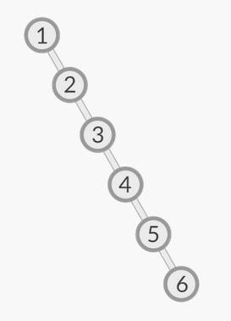

**Figure 13: Unbalanced Binary Search Tree**

* + The majority of operations performed on a Binary Trees are dependent on the height of the tree. This is why it is important to keep the tree’s height as small as possible, and when the height is as small is possible we say the tree is a balanced tree.
  + A balanced tree is a usefully property, because it reduces the worst case time complexity, of most BST operations, to O(log2 n).
  + A self-balancing tree is a tree that will rebalance itself after specific operations. An example of a self-balancing tree is a Red-Black Tree (shown in figure 14).
  + A Red-Black tree aims to keep the self-balancing property by coloring the nodes of the tree either red or black, while also preserving a specific sets of properties (described in the next section).

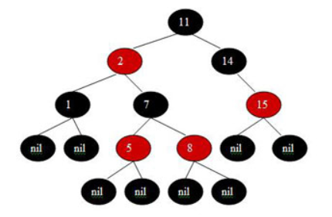

**Figure 14: Example of a red black tree**

* **Properties:**
  + A Red-Black is a binary search tree that contains the following properties.
    1. Every node is colored with either red or black.
    2. The root node is black.
    3. All leaf (nil) nodes are black nodes.
    4. Both children of a red node must be a black node.
    5. Every path from a node n to a descendent leaf has the same number of black nodes (not counting node n). We call this number the black height of n, which is denoted bh(n).
  + The incoming (inserted) node is always red.
    1. A double violation will occur if a child and parent node are both red.
       - We can resolve the violations with a recoloring of the node or a restructuring of the tree (rotation).
  + The properties of a Red-Black tree guarantee that the height of the tree will be O(log2 n).
* **Recoloring/Rotating (Insertion):** Recoloring and Rotating are methods that are used in order to rebalance a Red-Black tree.
  + Recoloring: is an operation that changes the color of a node in order to maintain the properties.
    1. We recolor when the parent, the parent’s sibling, and the child are all red. The solution is to recolor the grandparent red, the parent and the parent’s sibling black. (Figure 15)

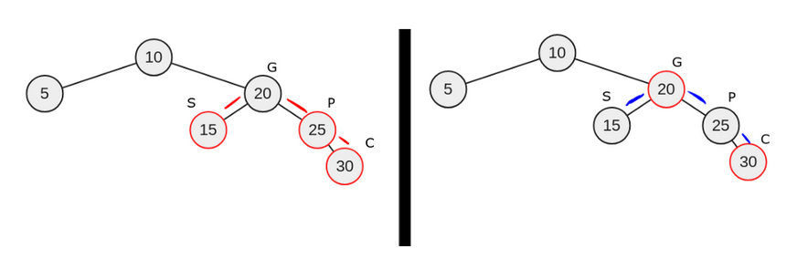

**Figure 15: Example of Recoloring**

* + A Rotation: is a binary operation that involves swapping and modifying the pointers of the grandparent, parent, and child nodes. Specifically, there are four types of rotation, a left left rotation, right right rotation, a left right rotation, and a right left rotation.
    1. Left Left Rotation: A left left rotation occurs when we have a double red violation on the left parent and the left child, which can be seen below in figure 16.
       - We resolve the violation by recoloring P to black, G to red and having the right node of P then point to g. Also t3 needs to be reattach from the right pointer of P to the left pointer of G.

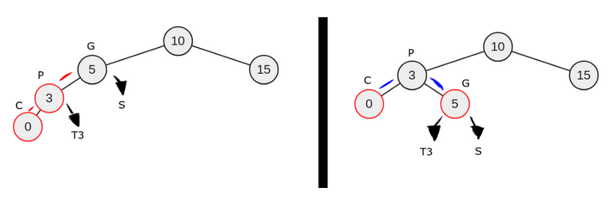

**Figure 16: Example of Left Left Rotation**

* + 1. Right Right Rotation: A right right rotation occurs when we have a double red violation of the right parent (relative to the grandparent) and right child both, which can be seen in figure 17.
       - We resolve the violation by recoloring P to black, G to red, and have the left pointer of P point to G. Also t3 need to be reattached to the right pointer of G.

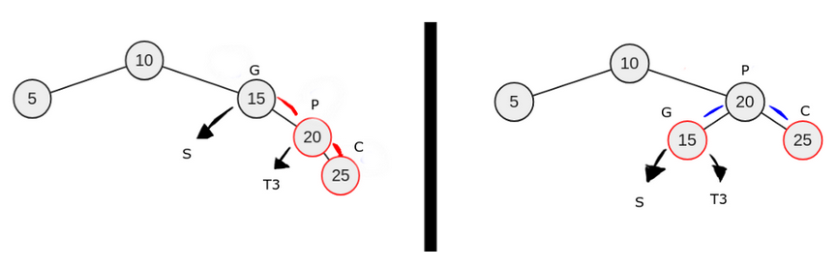

**Figure 17: Example of a right right rotation**

* + 1. Left Right Rotation: A left right rotation occurs when a double red violation occurs with the left parent (relative to the grandparent) and the right child (Example can be seen in figure 18). This rotation is sometimes referred to as a double rotation, because we can first rotate the parent with the child and then perform a left left rotation.
       - Left Right violation:
         * Grandparent (G) node is black
         * G’s left pointer points to the parent (P), which is red.
         * The sibling (S) of P is black or null
         * P’s right pointer points to the child (C), which is red
       - Violation Resolution:
         * Swap C and P but also maintain the BST order, so that C’s left pointer points to P.
         * Now we just perform a left left rotation.

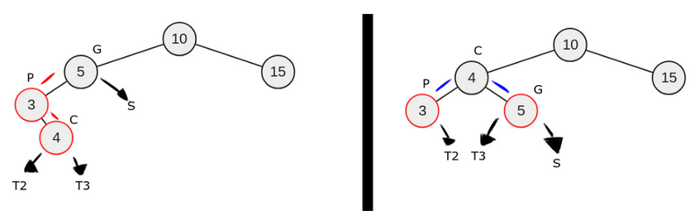

**Figure 18: Example of Left Right Rotation**

* + 1. Right Left Rotation: A right left rotation occurs when the grandparent’s right pointer points to the parent, which is colored red, and the parent’s left pointer points to the child, which is colored red (Example can be seen in figure 19). This rotation is also referred to as a double rotation.
       - Right Left Violation:
         * Grandparent (G) node is black
         * The right pointer of G points to the parent (P) node, which is red.
         * The sibling to the parent is black.
         * The left pointer of P points to the child (C) node, which is red.
       - Violation Resolution:
         * Swap C and P but also maintain the BST order, so that C’s right pointer points to P.
         * Perform a right right rotation.

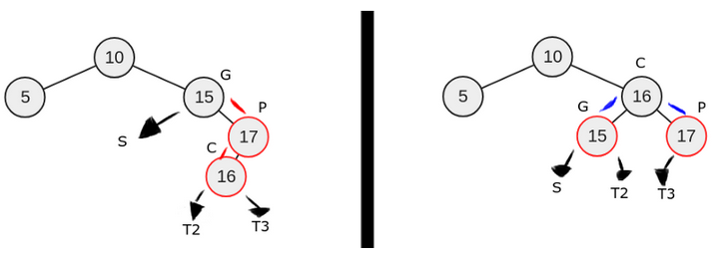

**Figure 19: Example of Right Left Rotation**

* **Operations:**
  + Search:
    - Same search operation described in the Binary Search Tree section.
  + Insertion:
    - Every node that is inserted is colored red unless it is the root node, which is black.
    - Insert according the node like you typically would with a binary search tree
    - Check for violation if a violation occurs, resolve the violation by either recoloring and/or restructuring, as shown in the previous section.
  + Removal: This operation is slightly more complex because we introduce the notion of a double black node, which is a black node that is deleted and replaced by a child node that is also black. Below we will work through the different cases of deletion. **Note:** We will denote the in order predecessor as *x*.
    - Case 1: *x* (the inorder predecessor) is red
      * Proceed as if it was a normal BST, replace the data in *x* with the node you were originally trying to remove and then remove x.
    - Case 2: *x* is black with a red child
      * Connect parent of *x* with child of *x*.
      * Delete *x*
    - Case 3: *x* is black and has a black child.
      * Replace node with its child.
      * This makes *x* a double black node, which needs to be transformed into a normal black node. This is done by looking at 6 different cases.
      * Case 3-1 (Terminal): If the root node is double black
        + Change color to black and you are done.
      * Case 3-2: *x* is double black, has a black parent, and a red sibling (seen below in figure 20).
        + If the red sibling is the right child node of the parent, we perform a left rotate from the parent. If the red sibling is the left child, we perform a right rotate from the parent.
        + The original parent (node 7 in figure 20) gets recolored red.
        + The original sibling (node 18 in figure 20) gets recolored black.

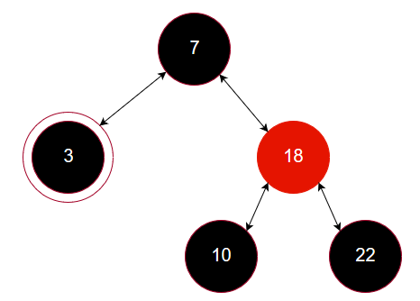

**Figure 20: Example of Delete Case 3-2**

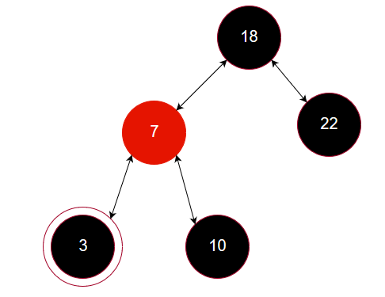

**Figure 21: Delete Case 3-2 after fix**

* + - * Case 3-3: *x* is double black, has a black parent, a black sibling, and the sibling’s children are both black (Seen below in figure 22)
        + We push the double black up to the parent.
        + Change the color of the sibling to red.
        + The new structure can be seen below in figure 23.

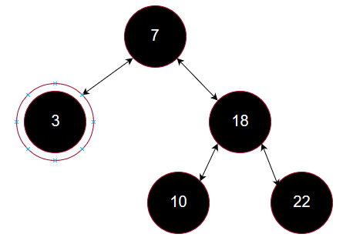

**Figure 22: Example of Delete Case 3-3**

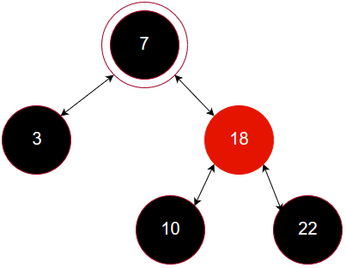

**Figure 23: Delete Case 3-3 after fix**

* + - * Case 3-4 (Terminal): *x* is double black, has a red parent (seen in figure 24), and both sibling’s children are black
        + We set the parent to black.
        + We set the sibling to red.
        + The new structure can be seen below in figure 25

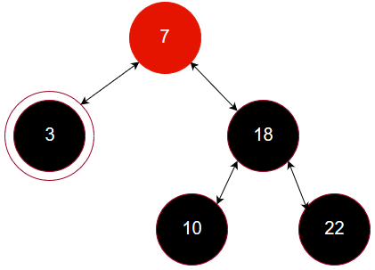

**Figure 24: Example of Delete Case 3-4**

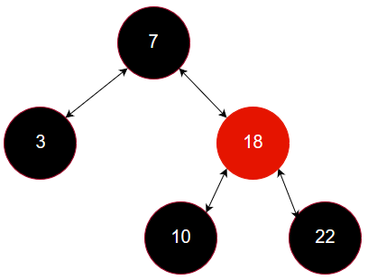

**Figure 25: Delete Case 3-4 after fix**

* + - * Case 3-5: *x* is double black, the sibling is black and the sibling’s inner child is red. (Seen below in figure 26).
        + If the Sibling node is the parent’s right child, we perform a right rotation around the sibling node. If the sibling node is the parent’s left child, we perform a left rotation around the sibling node.
        + We need to change the sibling’s color to red and the sibling’s inner child’s color to black after the rotation.
        + The new structure can be seen below in figure 27.

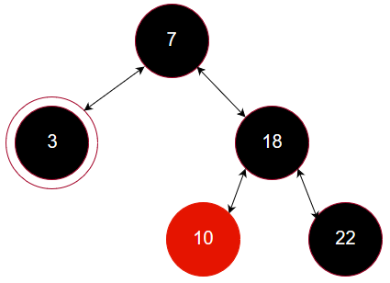

**Figure 26: Example of Delete Case 3-5**

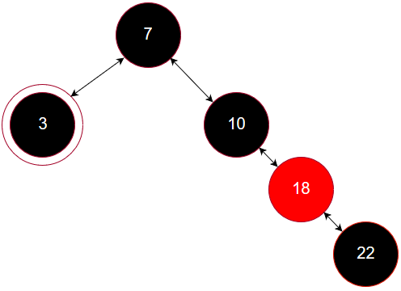

**Figure 27: Delete Case 3-5 after fix**

* + - * Case 3-6 (Terminal): *x* is a double black, *x*’s sibling is black and *x*’s sibling’s out child node is red (Seen below in figure 28). Note we don’t care about the parent node’s color or sibling’s inner child’s color, (colored gray in figure 28).
        + If *x*’s sibling is the right child of the parent, we perform a left rotation from the parent. If *x*’s sibling is the left child of the parent, we perform a right rotation from the parent.
        + After the rotation we recolor the double black to black, the parent’s node to black and the sibling’s outer child to black.
        + The new structure can be seen below in figure 29.

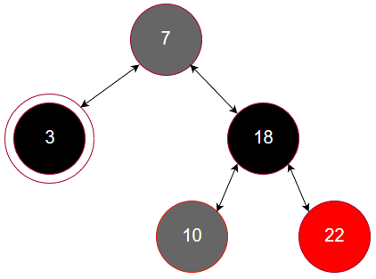

**Figure 28: Example of Delete Case 3-6**

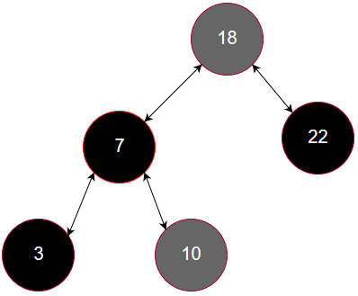

**Figure 29: Delete Case 3-6 after fix**

* **Time Complexities:** Time complexities of each Red-Black tree operation can be seen below in figure 30.

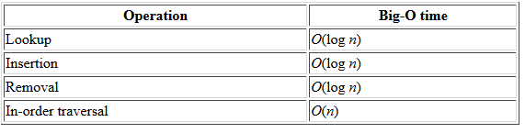

**Figure 30: Table of time complexities for each operation of a Red-Black Tree.**

* **Other Self-Balancing Trees:**
  + *AVL Tree* – The first designed self-balancing tree
  + *AA-Tree* – A slightly modified version of a Red-Black Tree, where the left child can only be a black node. This is to simplify the delete operation by reducing the number of cases that need to be handled.
  + *Splay Tree* – The main purpose of a splay tree is to keep the recently accessed or searched for nodes at the root. The reasoning for this is that in typically applications 80% of the access are on 20% of the items. Note that this is more like self-adjusting tree than a self-balancing tree, we can still have operations run in O(n) in the worst case but on average runs in O(log2n).
  + *B-Tree* – (<https://www.geeksforgeeks.org/b-tree-set-1-introduction-2/>)
* **References:**

1. <https://appliedgo.net/balancedtree/>
2. <https://towardsdatascience.com/red-black-binary-tree-maintaining-balance-e342f5aa6f5>
3. <https://www.geeksforgeeks.org/red-black-tree-set-1-introduction-2/>
4. <https://www.geeksforgeeks.org/red-black-tree-set-2-insert/>
5. <https://www.geeksforgeeks.org/red-black-tree-set-3-delete-2/>
6. <https://www.cpp.edu/~ftang/courses/CS241/notes/self%20balance%20bst.htm>
7. <https://www.topcoder.com/community/data-science/data-science-tutorials/an-introduction-to-binary-search-and-red-black-trees/>
8. <https://www.d.umn.edu/~gshute/ds/binary-tree/red-black-tree.xhtml>
9. <http://www.cs.toronto.edu/~wgeorge/csc265/2013/09/26/tutorial-3-red-black-tree-deletion.html>
10. <http://software.ucv.ro/~mburicea/lab8ASD.pdf>
11. <https://www.youtube.com/user/AMGaweda/videos>
12. <https://www.youtube.com/watch?v=CTvfzU_uNKE&t=1s>
13. <https://www.youtube.com/watch?v=aA-nLw28eUw>

**Hash Tables**:

* **Introduction:**
  + A Hash Table (or Hash Map) is a data structure used to map a specified key to a value (known as key/value pair). The storage medium is an array, where the key is mapped to a specified index of the array through the use of a hash function.
  + Hash Tables are useful for accessing data. They make it possible to look up the index of the array in constant time, through the hashing functions. Thus making the search, inert and delete operations constant time.
* **Hashing:**
  + Hashing is the technique/algorithm used to distribute a range of key values over a range of array indexes. Hashing is typically executed in two steps.
    1. Convert a key (typically strings or very large integers) into a smaller integer value using a hash function.
    2. The result of the hash function is mapped to an index in the array by taking the modulo (%) of the result with respect to the array size.
  + A good implementation of a hash table requires a good hash functions. A good hash function should have the following characteristics:
    1. Easy to compute.
    2. Key/Value pairs that are uniformly distributed across the storage array in order to reduce the number of collisions, which will be discussed in the next section.
  + There are typically two types of hashing functions. Cryptograph and Non-cryptographic hash functions. Cryptographic hash functions are some of the most commonly used hash functions as they are not dependent on array size, they are deterministic, they are designed to be one way functions, and they tend to distribute the data well even when there is only a slight change between inputs (keys). Non-cryptography hash functions are typically faster to compute but do not have some of the other benefits the cryptographic functions have.
  + A list of Cryptographic hash algorithms:
    1. MD5
    2. SHA-1
    3. RIPEMD-160
    4. Whirlpool
    5. SHA-2
    6. SHA-3
    7. BLAKE2
  + If we know all of the keys ahead of time, it is possible to generate a perfect hash function that will guarantee zero collisions, however the size of the array will be equal to the size of the key space.

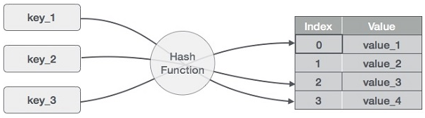

**Figure 31: Visualization of the hashing function, where keys are mapped to array indexes.**

* **Collisions:**
  + Ideally a hash function will distribute the range of keys uniformly over each index (or buckets) of an array. However, in practice this is difficult to achieve and collisions occur. A collision occurs when two different keys are assigned to the same index of an array. There are multiple ways to resolve these collisions.
  + *Linear Probing* is one of the easiest ways to resolve a collision. In linear probing if a collision occurs, we resolve the collision by looking for the next available index to insert the value into. However, an issue with linear probing is that it can cause clustering of data and slow down some of the operations such as, insertion, deletion, and search.
  + *Quadratic Probing* is very similar to linear probing in the sense that it searches for an open spot in the array. However, it eliminates the clustering problem we get from linear probing. It eliminates the clustering problem by squaring the spacing between each search for an open index.
  + *Double Hashing* is similar to linear probing except instead of incrementing by 1 to find an open slot, we increment by the hash of the next index value. We perform a second hash if a collision occurs.
  + *Separate Chaining* is one of the more commonly used collision resolution techniques. Separate chaining is implemented using linked list. Each index in the array is a linked list, so if a collision occurs we append the value at the end of the linked list, we can visualize it below in figure 32. The worst case scenario for separate chaining is when all of the elements are found in a single linked list. This scenario only happens when using a terrible hash function.

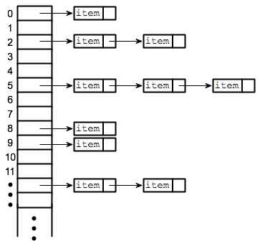

**Figure 32: Visualization of Separate Chaining Technique**

* **Time Complexities:**

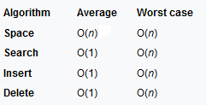

**Figure 33: Time and Space Complexity for Hash Tables**

* **Applications:**
  + Associative arrays, which are arrays where their indices are some arbitrary string or custom data object.
  + Database indexing
  + Caches
  + Object representation
* **References**

1. <http://everythingcomputerscience.com/discrete_mathematics/Data_Structures/Hash_Table.html>
2. <https://www.hackerearth.com/practice/data-structures/hash-tables/basics-of-hash-tables/tutorial/>
3. <https://www.youtube.com/watch?v=0M_kIqhwbFo>
4. <https://www.tutorialspoint.com/data_structures_algorithms/hash_data_structure.htm>
5. <https://en.wikipedia.org/wiki/Hash_table>
6. <https://en.wikipedia.org/wiki/Cryptographic_hash_function>

**Graphs**:

* **Introduction:** Similar to the Trees, graphs are non-linear data structures. However, they are not necessary hierarchical like Trees. Graphs are composed of two fundamental structures, vertices (nodes) and edges (connections). Vertices or node are similar to the nodes we saw in the Tree data structures, which is an element that holds data. Edges are the connections made between nodes, i.e. the lines that connect the nodes in figure 33.
  + Graphs are typically categorized as, *Directed* or *Undirected*. These two types of graphs tell us the relationship between the vertices.
    - *Directed:* In a directed graph the edge will specify which way you can travel between a pair of connected nodes.
    - *Undirected:* In an undirected graph you can travel back and forth between any connected pair of nodes.
  + Graphs can also be weighted or unweighted. If it is weighted it means that there is some weighted value or cost associated to edge between two nodes. Weighted graphs are used in algorithms like Dijkstra’s Algorithm, where we need to choose the shortest path.

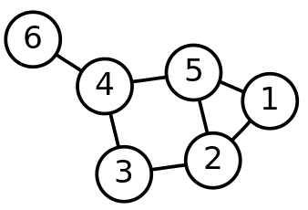

**Figure 33: Example of vertices and edges in a graph.**

* **Terms and Definitions:** It is important to understand some of the common terminology and definitions associated with graphs, which will be described in this section.
  + Vertex (Node): Is an element that contains some type of data.
  + Edge: Is a connection between nodes.
  + Graph: A graph is composed of a set of vertices and edges and can be mathematically represented as.
    - G = (V, E), where V is the set of vertices and E is the set of edges.
  + Each edge is represented as a pair (v, w) which are vertices contained in the set of vertices V (mathematically we can say v, w ϵ V).
  + Directed and Undirected graphs: (Described in the previous section)
  + Edge Cost (weight): Edges sometimes have a third parameter associated with them, which is cost or a weight, E(v,w,c).
  + Adjacent Node: Is a node that is directly connected to the node you are at. E.g node 3 is an adjacent node to node 4.
  + Path: A path is a series of vertices interconnected by edges.
  + Path Length: is the total cost of the edges along a path.
    - Unweighted Path Length: is the exact number of edges along the path.
    - Weighted Path Length: is the total cost of each edge along the path.
  + Cycle: In a directed graph, a cycle is a path that begins and ends with the same vertex and contains at least one edge.
  + Directed Acyclic Graph (DAG): is a special type of directed graph, which does not contain a cycle.
  + Completed Graph: Is a graph where all nodes are connected to all other nodes. I.e. Each node has *n* – 1 edges.
  + Dense Graph: Have a large number of edges. (|E| ≤ |V2|)
  + Sparse Graph: Have a small number of edges. (|E| ≤ |V|)
* **Operations:**
  + Add Node: Add a node to the graph.
  + Add Edge: Add a connection, between two nodes, to the graph.
  + Remove Node: Remove a node from the graph.
  + Remove Edge: Remove a connection, between two nodes, from the graph.
  + Search: Checks if there is a specified value in the graph.
  + Has Node: This checks if there is a connection, or edge, between two nodes.
* **Representations:** There are a couple of ways to represent the internal structure of graphs. The two main ways to represent the structure of graphs is with an adjacency matrix or an adjacency list.
  + *Adjacency Matrix*: This method represents a graph using a two dimensional array, where the dimensions are the vertices and the elements of the matrix are the edge costs from vertex to vertex. An example of an undirected, unweight graph represented as an adjacency matrix can be seen below in figure 34. Every 1 in the matrix represents a path from one vertex to another vertex.
    - The space complexity is this representation is O(V2), where v is the number of Vertices.
    - The time complexity is constant time lookup to find edge weight.
    - This representation is not a good representation for a sparse graph. There will be a large number of zeros, since there is a small number of edges compared to vertices.

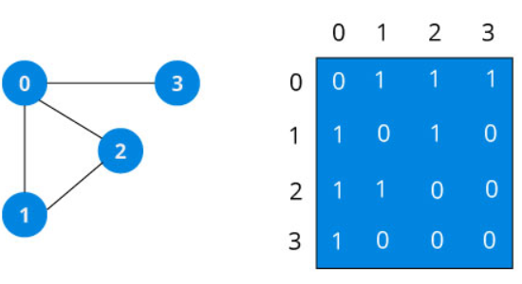

**Figure 34: Undirected, unweighted graph represent as an adjacency matrix**

* + *Adjacency Lists*: In an adjacency list each node in the graph will have a list of nodes adjacent to it. We can represent the list with a Hash Map that handles collisions using a linked list, where each node in the graph is a key in the Hash Map. An example of a directed unweighted graph and the adjacency list representation can be seen below in figure 35.
    - In this method if we want to see if two nodes are connected it will take, O(d) time, where d is the degree of the node. The most the degree can be for any give node is |V|.
    - The space is complexity is significantly less if the graph is sparse, O(V+E).

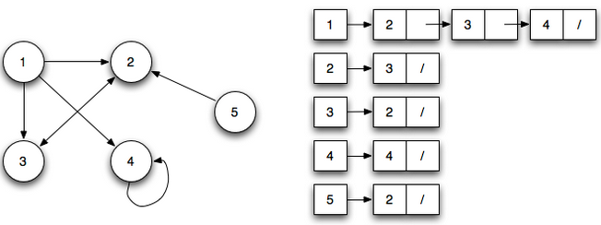

**Figure 35: Directed, unweighted graph represented as an adjacency list**

* **Shortest Path:**
  + Unweighted: For unweighted paths, each edge does not have an associated cost. For the shortest path problem, this just means the lowest number of edges from one vertex to another. In order to solve the shortest path problem, a starting vertex is needed. We will use the graph in figure 36 to demonstrate the shortest path problem, with the starting vertex being V2, which means the distance at V2 is 0. Let’s look at all of the shortest paths from V2:
    - After locating our starting point we will look for the closest nodes from V2 with a length of 1. This will be V0 and V5­.
    - Next we look for the shortest paths from V2­ with a length of two. This will be all of the adjacent nodes connected to V0 and V5, which is highlight in figure 37.
    - We then continue this process until all of the nodes have been visited. All of the nodes with their shortest path from V2 is shown in figure 38.
    - The method we just went through is call **Breadth-First Search**, which is the process of searching vertices in layers, in which those closest to the starting node are evaluated first. Breadth-First Search is discussed in more detail in the next section.

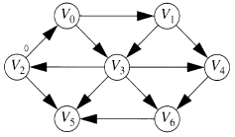

**Figure 36: Unweighted Directed Graph with Starting Vertex being V2**

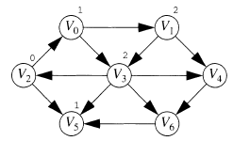

**Figure 37: Nodes with a Shortest Path Length of Two or Less (Starting from Node V0)**

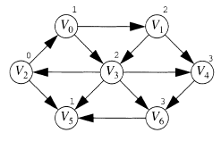

**Figure 38: Shortest Path Distance for Each Node with the Starting Node at V2 in Unweighted Directed Graph**

* + Positive weighted (Dijkstra): The solution for the shortest path problem is different for different types of graphs. In this section we will be looking at the shortest path problem for a positive-weighted graph, which is Dijkstra’s algorithm. In the previous example we update the distance cost from one node to another node by 1, which we can represent mathematically as, Dw = Dv + 1. Where Dw is equal to shortest path distance of the new node, Dv is equal to the shortest path distance of the node we are currently located, and 1 was equal to the edge cost (1 because it was an unweight graph). For the positive weighted graph this equation chances slightly, Dw = Dv + Cv,w where, Cv,w is equal to the edge cost from node V to node W. However, we will only update Dw if the cost of Dw is larger than the cost of the Dv + Cv,w. The reason for this is the algorithm is deciding whether the node V should be used on the path if the cost is cheaper than the current cost than it is a valid option for the path. Figure 39 tries to demonstrate a typical situation in Dijkstra’s algorithm.

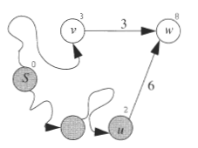

**Figure 39: Example of Dijkstra’s Algorithm Lowering the Distance value from 8 to 6.**

* + - Figure 39, shows us that the algorithm updated the shortest distance value of node W, when it was being evaluated at node U, to 8. However, when we come to node V and evaluate the cost of the shortest distance value we update Dw because Dv = 3 and Cv,w = 3, which means Dv + Cv,w = 6, which is less than the current value of Dw.
    - When implementing Dijkstra’s algorithm we can use the same queue data structure, and add all of the adjacent nodes onto the queue. As long as we use the new update rule the algorithm will work. This however is not the most efficient method; a more efficient method would be to use a priority queue. The priority queue will insert an object that contains the node W and Dw whenever we lower Dw. Then to select a new vertex V for visitation, we repeatedly remove the minimum item (based off of distance) from the priority queue until an unvisited vertex is available to evaluate.
    - The stages of Dijkstra’s algorithm can be visualized below in figure 40.

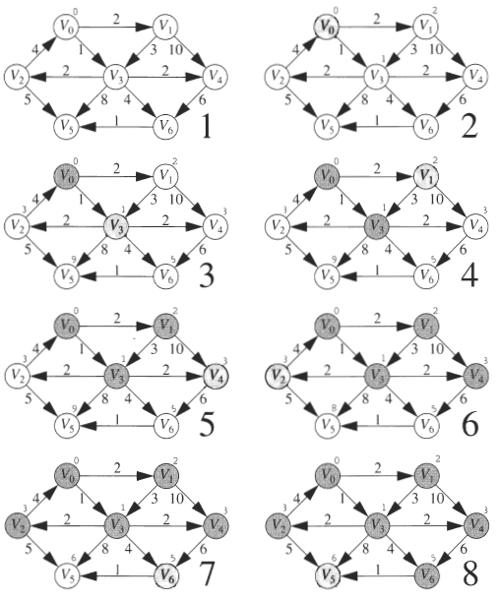

**Figure 40: Visualizing the Different Stages of Dijkstra’s Algorithm**

* + Negative Weighted (Bellman-Ford): When negative weighted edges are added to the mix, Dijkstra’s algorithm fails. This requires a more general solution that allows for negative edge costs. An example of a graph with a negative edge cost can be seen in figure 41. Negative weighted graphs do present the possibility of running into a negative-cost cycle, which is an infinite loop such as going from V3, V4, V1, V3, V4, … The algorithm used to determine the shortest path, should find the shortest paths or report back the existence of a negative-cost cycle. The solution to the shortest path problem for negative weighted graph is the Bellman-Ford algorithm. The Bellman-Ford algorithm combines the algorithms used in the weighted and unweighted problems. More specifically we will use the queue data structure, which is used in the unweighted problem, and the update rule used in Dijkstra’s algorithm, which is used in the positive weighted problem. We know that a vertex can dequeue at most |V| times, therefore we know if a vertex dequeues more than the total number of vertices than we have detected a negative-cost cycle.

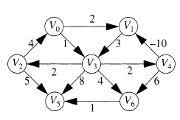

**Figure 41: Example of a Directed Graph with Negative Weighted Edges.**

* + Acyclic Graphs (Topological sort): Acyclic graphs, as the name implies, do not contain cycles. This allows us to simplify the solution for the shortest path problem of the previous section, since we no longer have to worry about negative-cost cycles. The solution for this type of graph is a topological sort.
    - *A topological sort:* orders nodes in a directed acyclic graph such that if there is a path from node U to node V, then node V appears after node U in the ordering. E.g. A graph can be used to represent prerequisites for a specific university course. A topological ordering of the courses is an ordering that does not violate the prerequisite requirement.
    - In a simplified version of the topological sort:
      * First find any nodes without incoming edges. More formally we say find the nodes with an indegree of zero.
      * Print the node and logically remove it and it’s edges from the rest of the graph. In practice we do not physically remove the node from the graph but we decrement the indegree count so as to act as if we are removing the edge from the nodes.
      * We continue with this until we have removed every node from the graph. And the order in which the nodes where removed tells us the topological order of the graph.
    - We can implement the algorithm in linear time by placing all unprocessed indegree 0 nodes onto a queue. To find the next vertex in the topological order, we merely get and remove the front item from the queue. When a vertex has its indegree lowered to 0, it is placed onto the queue. If the queue empties before all the vertices have been topologically sorted, the graph has a cycle. The run time is linear because of the same reasoning used in the unweighted shortest-path algorithm (BFS).
    - We apply topologically sorting to the shortest-path problem for acyclic graph by visiting each node in topological order. This works because we are guaranteed that the Dv value cannot be lowered, because it no longer has an incoming edge. Figure 42, shows the stages of the acyclic shortest-path algorithm.

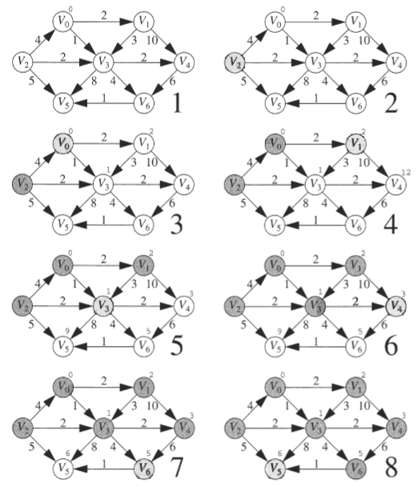

**Figure 42: Stages of the Acyclic Graph’s Shortest-Path Algorithm**

* **Breadth-First Search(BFS) and Depth-First Search (DFS):**
  + BFS: The process of searching vertices in layers, where those that are closest to the starting Vertex is evaluated first. This is done by starting at the start Vertex and push all of the vertices adjacent that node on a queue. Once that node has been visited, we then examine the next vertex on the queue. We then push all of the new vertex’s adjacent nodes, that have not been visited, onto the queue. An example of BFS on an unweighted directed graph can be seen below in figure 43.

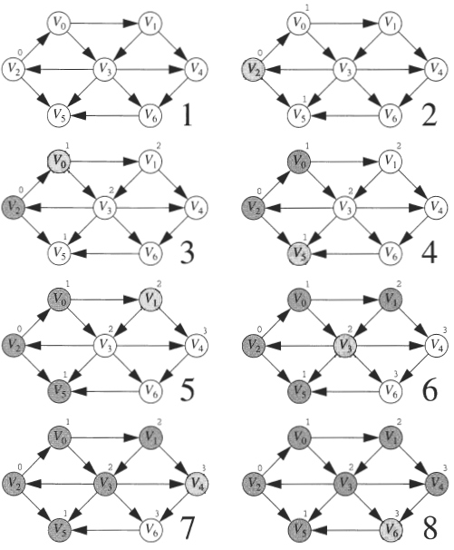

**Figure 43: Visualization of BFS on an Unweighted Directed Graph**

* + DFS: Depth First Search (DFS), searches outwards of the starting node. It is implemented very similarly to BFS, however the main difference in the search is that instead of using a queue, which is used in BFS, to store adjacent nodes we use a stack.
* **Applications:**
  + Social Media Networks
  + Representing computer networks
  + Representing maps (E.g. Google Maps)
* **References:**

1. <https://www.tutorialspoint.com/data_structures_algorithms/graph_data_structure.htm>
2. <https://medium.freecodecamp.org/a-gentle-introduction-to-data-structures-how-graphs-work-a223d9ef8837>
3. <https://www.geeksforgeeks.org/graph-data-structure-and-algorithms/>
4. Data Structures and Problem Solving Using C++ - Mark Weiss
5. <https://www.programiz.com/dsa/graph>
6. <https://www.khanacademy.org/computing/computer-science/algorithms/graph-representation/a/representing-graphs>